22.66: a) Charge enclosed:
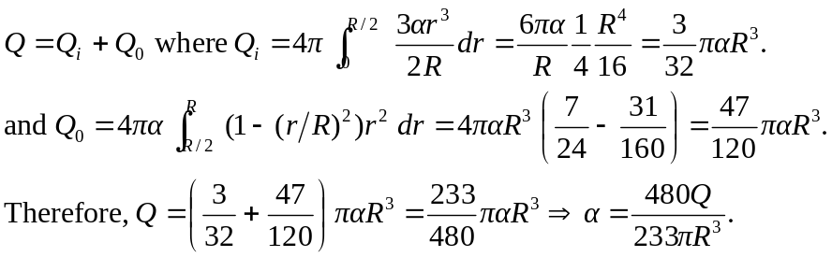
b)
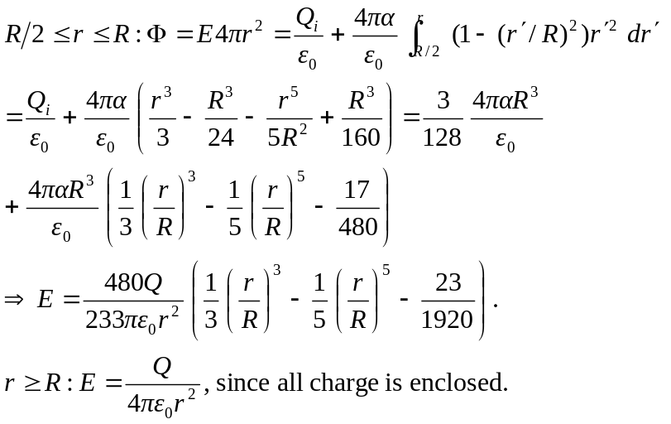
c) The fraction of  between 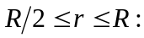
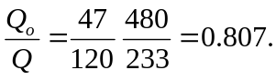
d) 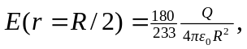 using either of the electric field expressions above, evaluated at 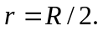
e) The force an electron would feel never is proportional to which is necessary for simple harmonic oscillations. It is oscillatory since the force is always attractive, but it has the wrong power of to be 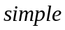 harmonic.

